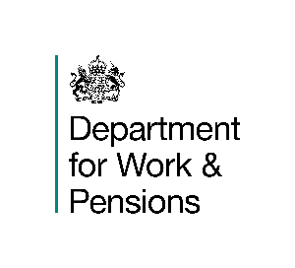
By email  To: LA Homelessness teams | Address:  Email:  Date: | Vicki Kennedy  Housing Policy Division  Caxton House  Tothill Street  London  SW1H 9NA  housing.policyenquiries@dwp.gov.uk  29 January 2026
Dear colleagues
Clarification of the Homeless Hostel definition for the Shared Accommodation Rate
I am writing to highlight a recent clarification made to the Universal Credit (UC) decision makers’ guidance about the homeless hostel exemption to the Shared Accommodation Rate (SAR) of the Local Housing Allowance (LHA).
In UC, the SAR applies to single claimants under the age of 35 who are renting privately. A claimant is entitled to an exemption from the SAR and can receive the one-bedroom LHA rate if they have:
- spent three months or more (whether continuously or not) in a homeless hostel, and
- been offered and accepted support services aimed at rehabilitation or resettlement in the community.
The guidance has been updated to reflect that, for the purposes of this exemption, some night shelters may be considered to meet the definition of a homeless hostel. This clarification can be found in Chapter F3 Housing Costs Element: Support for renters of the Advice for decision making: Staff-guide.

How local authorities can help
Claimants can request this exemption in the usual way, such as through their UC journal, and should provide any available evidence confirming their stay in a hostel or night shelter. Decisions will continue to be made on a case-by-case basis.
Please ensure this information is shared with all relevant staff, particularly those supporting individuals to secure housing or to make and maintain their UC claims.
Further information about the various exemptions to SAR can be found in the Renting from a private landlord section on the Housing Costs and UC pages of www.gov.uk
If you have any questions about the content of this letter, please contact housing.policyenquiries@dwp.gov.uk
Yours faithfully

Vicki Kennedy
Housing Policy Director, Housing Policy Division

